1. Advantages of Stream API:
   1. Stream API helps us to achieve more results with less code.
   2. It also allows you to process data parallel in multithreads without worrying about multithreading.
2. 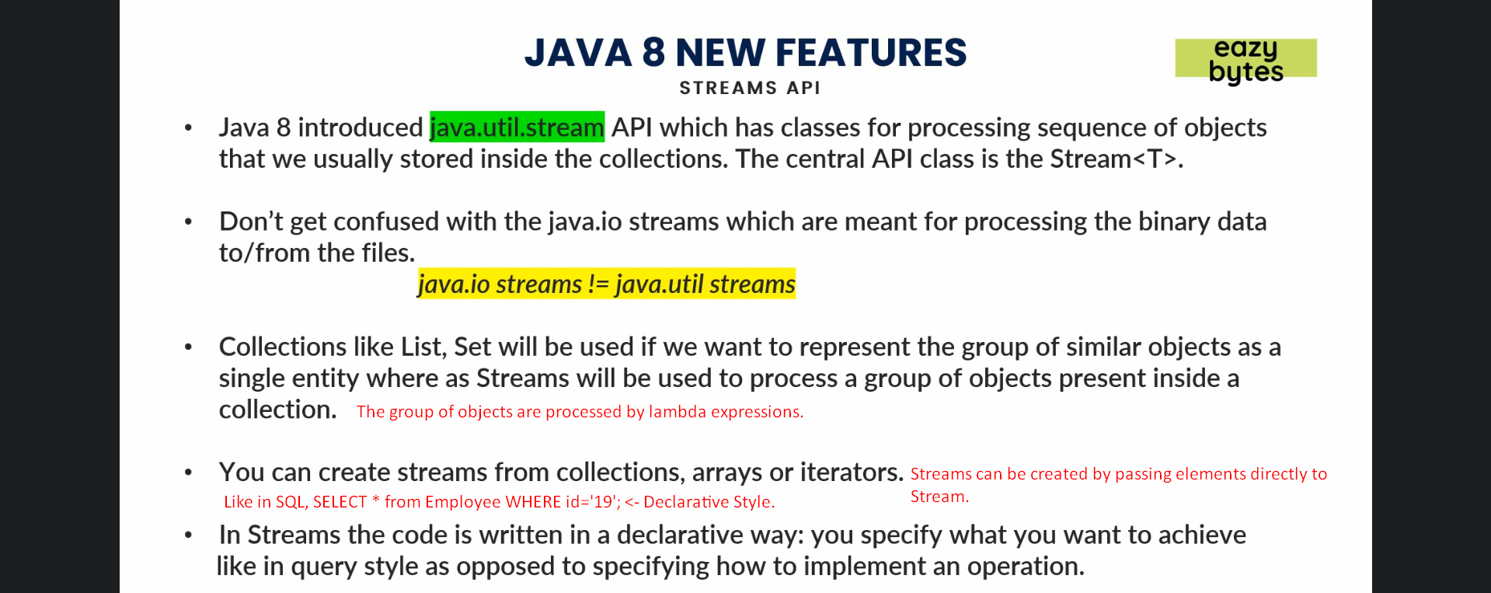
3. 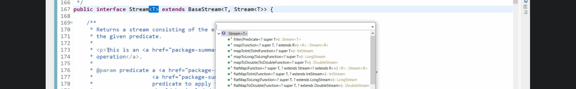
   1. Package: java.util.stream.
   2. All the classes and interfaces inside this package constitute Stream API.
   3. Stream<T> extends BaseStream<T, Stream<T>> is the base interface.
   4. Above T means, stream can process a group of objects of any type.
   5. Stream<T> Interface has many utility methods.
4. Let’s see different ways to create a stream.
   1. Default Collection.stream() was introduced to get stream for any collection.
   2. Stream is not a memory location. So if you create a stream from a collection, it doesn’t allocate separate memory to those items in the collection.

|  |  |
| --- | --- |
| **Collection** | **Stream** |
| Collection will always hold the data of elements.  Physical holding of elements. | It is just representation for those elements |
|  | When we try to process those elements, an output will be formed and transformed into another new collection object. |
|  |  |

1. 
2. 
3. 